**CURRICULUM VITAE**

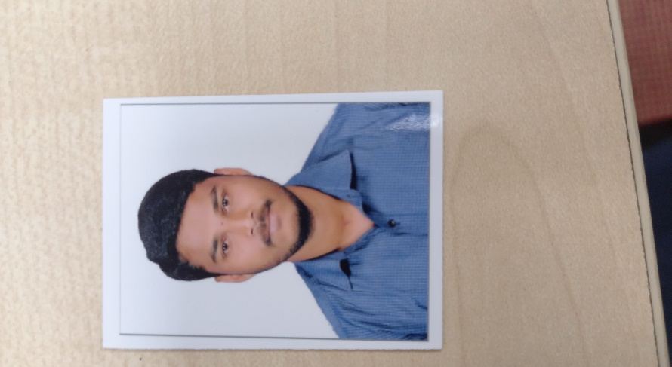

**Karigowda S**

**New Project Development and Process Management Asst. Manager**

**D.O.B.:** 06-Jun-1992

**Nationality:** India

**Location:** Bengaluru, India

**Contact:** +91-9916575292

**E-Mail:** karigowdarmt@gmail.com

**Aiming for a Challenging Role in New Project Development and Process Management -Automotive Industries / Engineering Industries to Utilize My Skills.**

**EXPERIENCE SUMMARY**

* **Mechanical Engineer** with **6 +Year** of work experience in New Project Process Development and Process Quality Assurance Department.
* Gained experience in Complete **Project Management** & New Product Development process.
* Knowledge about Process Planning, Part Development, APQP and PPAP Such as PFD, PFMEA, CONTROL PLAN and OPERATING STANDARD etc..
* Responsible for New Vendor Development for manufacturing of Tool/Fixture/Gauge/SPM.
* Good experience in New/Manufacturing Process Planning and Development, Fixtures, SPM’s, Robo Fixture, Cycle Time Study, and Tack Time Calculation.
* Process and Product improvement process step reductions thorough proper process DVP
* Experience in handling diverse range of Weld Assy., Tooling Assy., Fabrication Process, Sheet metal, Tubular parts of Exhaust Systems, Frames & Special Purpose Machine etc.,
* Self-QAV Conducting with CFT Team.
* New Product Audit Conduct with customer and Implement.
* Experience in Preparation of New Product and Process Development Internal and External Documents.
* Conducting team feasibility commitment, Deciding feasibility & Process flow of the part.

**PROFESSIONAL EXPERIENCE**

**RUCHA ENGINEERS PVT LTD., MYSORE: JAN-2021 TO PRESENT**

**ROLE: New Project Development and Process Management Asst. Manager**

**DESCRIPTION:** Incepted in the year 1987, Rucha group over the years has transformed into a global tier-1 automotive component manufacturer and supplier of press parts, structural elements, transmission systems, exhaust systems, engine related assemblies and plastic moulded parts and components to passenger car, commercial vehicle, two-wheeler and three-wheeler OEMs worldwide. With 10 world-class manufacturing facilities and 1 R&D centre in spread across 5 locations in India, Rucha group is on an above exceptional growth trajectory clocking a sale of above 100 million USD in 2017-18. The company is one of the leading car component suppliers and amongst the top 3-wheeler automotive component supplier in India. Rucha offers exceptional engineering edge and competitive value that in turn provides competitive edge in the market.

**Products:** Frame Comp Assy, Handle Bars, Engine Mounts, Center Stand, Front Fenders, Motorcycle Fuel Tank, Moped Fuel Tank, Silencers, Chain Case.

**PROJECTS HANDLED** Presently Working on BS-VI Project for Apache 2V and 4V Frame Comp Assy., U368 Frame Comp Assy., Apache Fuel Tank, and U368 Fuel Tank.

**RESENT ROLE AND RESPONSIBILITIES:**

* Responsible for **Project Management** & New Product Development process.
* Responsible for New Vendor Development for manufacturing of Tool/Fixture/Gauge/SPM.
* Layout Making and New Project Installation.
* Responsible for New/Manufacturing Process Planning and Development, Fixtures, SPM’s, Robo Fixture, Cycle Time Study, and Tack Time Calculation.
* Preparation and control of Process Documents like PFMEA, Process Plan, PFD, Control Plan, Capacity Verification Sheet, Manufacturing Control Plan and Operating Standard for All Model etc.,
* Responsible for introducing the Poka-Yoke (mistake proofing) while development and Production.
* DAP Finalization and Manufacturing.
* All parts BOM Creation and Updating.
* Audit Conducting with Customer for Process and Products.
* Fixture / Line trial taken and Event part send to Customer.
* Conducting process and product audits of self and for team members.
* Development, Validation of Sheet metal, Tubular and Machined parts.
* Conducts root-cause analysis, develops and deploys corrective and preventative action plans.
* Ensuring process validation and addition of same in standards.
* Analysis on occurrence, outflow of warranty issues and Taking corrective actions for top concerns.
* Time study and Line capacity analysis.
* Conducting team feasibility commitment, deciding feasibility & process flow of the part.
* Skill enhancement/Knowledge improvement of team via OPL and Identification of Q component stage wise.
* Fixture manufacturing as per drawing and Trailing as customer Requirement.
* Conduction of Process & Product audits for all Model.
* Process Planning and Mapping for new products.
* Participate with Cross functional team (CFT) activity.
* Modification in standard products as per customer’s special/Specific requirement.
* Achieving the targets as per the management plan.
* Monitoring and Ensure effective implementation of 5’S, Poka-Yoke and Kaizens.
* Identify requirements of critical Spares and their Maintenance.

**BADVE ENGINEERING LTD., BANGALORE: JAN-2017 TO JAN-2021**

**ROLE: New Process Development Engineer.**

**DESCRIPTION:** Badve Engineering Ltd. is an ISO 9001:2008 certified company. The company'smanufactured products are readily available for the leading auto-industries like HONDA TWO WHEELER, ROYAL ENFIELD, and MAHINDRA REVA, SCANIA.

**Products:** Exhaust Systems, Sheet Metal Parts, Frame Body Parts for two Wheeler, Sub Assy’s for twoWheeler, and Injection Moulding Parts for Two Wheeler.

**PROJECTS HANDLED** BS-VI Project for Frame Comp RR/FR, Muffler Assy Exh, Handle Assy, Grip Rear andHinge Body Cover **(Honda Scooter & Motorcycle).**

**PRESENT ROLE AND RESPONSIBILITIES:**

* Conduct morning meeting with to associate share day-to-day improvement & concerns.
* Customer 2D drawing feasibility Study and closing technical issues.
* Fist Part Approval for the Whole Process.
* Preparation and control of Process Documents like PFMEA, Process Plan, PFD, Control Plan, Capacity Verification Sheet, Manufacturing Control Plan and Operating Standard for All Model etc..,
* Responsible for introducing the Poka-Yoke (mistake proofing) while development and Production.
* QAV Conducting with Customer.
* Conducts root-cause analysis, develops and deploys corrective and preventative action plans.
* Time study and Line capacity analysis.
* Conducting team feasibility commitment, deciding feasibility & process flow of the part.
* Preparation of Quality documents for New Model line displays.
* Process Quality Manpower Handling.
* Fixture manufacturing as per drawing and Trailing as customer Requirement.
* Press tool Manufacturing and Trailing as per Customer given Drawing.
* Child Part Gauges DAP Finalization and Manufacturing.
* Conduction of Process & Product audits for all Model.
* Process Planning and Mapping for new products.
* Participate with Cross functional team (CFT) activity.
* New Model Project Planning and Co-ordination with vendors for Development.
* Development, Validation of Sheet metal, Tubular and Machined parts.
* Modification in standard products as per customer’s special/Specific requirement.
* Countermeasure and Action Plan Preparation for customer complaints.
* Giving Awareness regarding past problems to the operators & inspector.
* Achieving the targets as per the management plan.
* Line layout planning, installation and commissioning of new lines.
* Preparation of Work Instruction and other PPAP documents.
* Fixture / Line trial taken and Event part send to Customer.
* Monitoring and Ensure effective implementation of 5’S, Poka-Yoke and Kaizens.
* Identify requirements of critical Spares and their Maintenance.

**ADDITIONAL RESPONSIBILITIES**

* Responsible for preparing all APQP controlled documents.
* Responsible for preparing Weekly Review presentation of plant on every Saturday.
* Responsible for preparing Internal MRM presentation of Development on monthly basis.
* Responsible for preparing Customer visit presentation
* Responsible for internal Audit
* Process Audit verification (Monthly)
* QMS Audit of plant (Quarterly)
* 5 S Audit of Plant. (Weekly)
* Responsible for making new Kaizen in every month & their Implementation.

**OMAX AUTO’S LTD., BANGALORE: JUN-2010 TO MAY-2011 [DET]**

**ROLE:** Tool Room DET.

**DESCRIPTION:** Established in 1983, the company specializes in sheet metal components, tubular components

and machined components. Focused on performance, OMAX is amongst the prime OEM (parts and assembly)

Supplier

**Products:** Sheet Metal (Press Tool) Parts, Frame Body Parts for two Wheeler, Sub Assy’s for twoWheeler, and Machining Parts for Two Wheeler.

**Customer:** Nissan Motor Co. Ltd, TVS, Toyota.

**PROJECTS HANDLED:** Nissan Motors Sheet Metal Component Press Tools, TVS Frame Sheet MetalComponent Press Tools, Toyota Sheet Metal Component Press Tools.

**EDUCATION:**

* **M-Tech in Machine Design:** 2016 Passed Out With 69.5 **%** From U. B.D.T.C.E Davangere, Karnataka
* **B.E in Mechanical Engineering:** 2014 Passed Out With 71.10 **%** From P.E.S.C.E Mandya, Karnataka
* **Diploma in Tool and Die Making:** 2010 Passed Out With 74.67 % From GT&TC Hassan, Karnataka

**TECHNICAL SKILLS & TRAINGING:**

* Computer Basics.
* MS Office.
* Auto CAD - Drafting & Detailing.

**PERSONAL PROFILE:**

* Name : Karigowda S
* Father Name : Shivegowda
* Date of Birth : 06-06-1992
* Marital Status : Married
* Gender : Male
* Nationality : Indian
* Languages Known: Kannada, English, and Hindi.
* Duration for joining: 30 days (from the Date Offer Letter Received).

**DECLARATION:**

I do hereby declare that all the above furnished particulars are true and correct to the best of my knowledge and believe.

Date: 04 / 11 / 2022

Place: Mysore. Yours Faithfully